**Online Resident/Visitor Registration of Rented Buildings**



# Session (2011-2015)

# Program

Bachelor in Computer Science (Honors)

# Submitted By

**Shahbaz Khan HU(2019)2011**

**Asad Khan HU(2017)2011**

# Supervised By

# Mr. Aamir Javed

**Programmer, IT-Department**

**HAZARA UNIVERSITY, MANSEHRA**

### FINAL APROVAL

This is to certify that we have checked the project software titled **“Online Resident/Visitor Registration of Rented Buildings”** submitted by the following student of BCS 8th.

**Roll No. Name Registration No.**

24684 Shahbaz Khan HU(2019)2011

24624 Asad Khan HU(2017)2011

It is our judgment that this project software is of sufficient standard to warrant its acceptance by the Department of Information Technology, Hazara University, Mansehra.

**COMMITTEE**

1. External Examiner
2. Internal Examiner
3. Supervisor
4. Head Of Department

**DEDICATION**

We dedicate our project to those respectable personalities whose prayers always give us gift of success and who encourage us in every difficult time. May, ALLAH give them happiness in both lives.

**DECLARATION**

We hereby declare that this software, neither as a whole nor as a part has been copied out from any source. It is further declared that we developed this report on the basis of our personal effort under the guidance of our project supervisor Aamir Javed.

We further declare that this software and all associated documents, and records are submitted as partial requirements for the degree of BS computer science.

Submitted by:

Shahbaz Khan Signature:________________

Roll Number : 24624

Asad Khan Signature:________________

Roll Number : 24624

**ACKNOWLEDGMENT**

With the name of ALLAH, the most gracious and merciful, who gifted us blessings, strength and mental powers, without which we could not complete this project. Before we get into think of the things we would like to add a few heartfelt words for the people who were part of this project in numerous ways. People who gave unending support right from the stage project idea were conceived. In particular we are extremely indebted our teacher and supervisor of this project Mr. Aamir Javed, and also we are thankful to our class fellows for their support. Vivacious and exuberant approach always put us on right track. We are extremely thankful to our beloved Parents and family whose prayers and continuous encouragement made the successful completion of this project possible.

**PROJECT IN BRIEF**

Project Title: Online Resident/Visitor Registration of Rented Buildings

Submitted by: Shahbaz Khan

Asad Khan

Supervised By: Mr. Aamir Javed

Starting Date: June 2015

Completion Date: September 2015

**Software Used:** **Visual Studio.Net 2010 (ASP.Net)**

**C Sharp (C#)**

**SQL Management Studio 2008**

**SQL Server 2008**

**HTML / DHTML**

**CSS**

**Java Scripts**

Operation System: Windows XP/ 7 with Internet Explorer

**TABLE OF CONTENT**

CHAPTER 1 INTRODUCTION

1.1 ABOUT PROJECT 1

1.2 NEED OF COMPUTERIZATION 1

1.3 SCOPE OF PROJECT 2

1.4 OBJECTIVES 3

1.5 PROJECT PLAN 4

1.6 WORK BREAK BOWN AND PROJECT SCHEDULE 5

1.6.1 PROCESS MODEL 5

1.6.2 TOTAL TIME ALLOCATION 5

1.6.3 PROJECT TIME SCHEDULE 5

1.6.4 GANTT CHART FOR PROJECT DEVELOPMENT 6

1.6.5 OUTPUTS FROM THE PROJECT 6

1.6.6 REPORT OF PROJECT 7

1.7 CONCLUSION 7

CHAPTER 2 EXISTING SYSTEM

2.1 EXISTING SYSTEM 8

2.2 ANALYSIS & DRAW BACKS OF EXISTING SYSTEM 9

2.3 CONCLUSION 11

CHAPTER 3 PROPOSED SYSTEM

3.1 PROPOSED SYSTEM 12

3.2 FEATURES OF PROPOSED SYSTEM 12

3.3 ADVANTAGES OF THE PROPOSED SYSTEM 14

3.4 SYSTEM ARCHITECTURE 15

3.5 Feasibilty Repot 15

3.5.1 Operational Feasibilty 15

3.5.2 Technical Feasibilty 16

3.6 CONCLUSION 16

CHAPTER 4 SYSTEM DESIGN

4.1 DESIGN 17

4.2 DATABASE DESIGN 17

4.2.1 LOGICAL DATABASE DESIGN 17

4.2.2 Dataflow Diagram Diagrams 17

4.3 Entity Relations Diagram 17

4.3.1 BASIC Shapes Used in ERD 23

4.3.2 ENTITY Relationship Diagram for this project 24

4.3.3 Data Base Diagram for this project 25

4.3.4 Entities with Attributes 25

4.4: FLOW CHART 32

4.5 CONCLUSION 38

CHAPTER 5 SYSTEM TESTING & IMPLEMENTATION

5.1 TESTING STRATEGIES 39

5.2 PROJECT TESTING REPORT 45

5.3 DURING DEVELOPMENT TESTING 46

5.4 IMPLEMENTATION 46

5.5 CONVERSION 47

5.5.1 DIRECT CONVERSION METHOD 47

5.5.2 GRADUAL CONVERSION METHOD 47

5.5.3 PILOT CONVERSION METHOD 48

5.5.4 PARALLEL CONVERSION METHOD 48

5.5.5 PROPOSED CONVERSION METHOD 48

5.6 CONCLUSION 48

cHAPTER 6 uSER mANUAL

6.1: Home/Index Page 49

6.2: Police Station Login Form 50

6.3: Police Station 51

6.4: Add Person Information Form 52

6.5: Add Hostel Information Form 53

6.6: Add Hotel Information Form 54

6.7: View Hostel Information Form 55

6.8 Detail Hostel Information Form 56

6.9: Update/ Delete Person Information Form 57

6.10: Update/ Delete Police Station Information Form 58

6.11: Detail Hotel Information Form 59

cHAPTER 7 dATA dICTIONARY

References

**LIST OF FIGURE**

Figure 4.1: Level “0” DFD (Context Level) 18

Figure 4.2: Level “1” DFD 20

Figure 4.3: Level “1” DFD 20

Figure 4.4: Level “2” DFD 21

Figure 4.5: Level “2” DFD 22

Figure 4.6: Entity Relation Diagram 22

Figure 4.7: Database Diagram 22

Figure 4.8: Admin 32

Figure 4.9: Area Information  32

Figure 4.10: Building Information  32

Figure 4.11: Rented Buildings  32

Figure 4.12: Hostel Information  32

Figure 4.13: Hostel Room Information  32

Figure 4.14: Hotel Information  32

Figure 4.15: Hotel Room Information  32

Figure 4.16: Hostel Visitor  32

Figure 4.17: Hotel Visitor  32

Figure 4.18: News & Events  32

Figure 4.19: Person Information  32

Figure 4.20: Police Station

Figure 4.21: Login 38

Figure 4.22: Change Password 38

Figure 4.23: Save Record 38

Figure 4.24: Update Record 38

Figure 4.25: Search Record 38

Figure 4.26: Delete Record 38

Figure 6.1: Home/Index Page 49

Figure 6.2: Police Station Login Form 50

Figure 6.3: Police Station 51

Figure 6.4: Add Person Information Form 52

Figure 6.5: Add Hostel Information Form 53

Figure 6.6: Add Hotel Information Form 54

Figure 6.7: View Hostel Information Form 55

Figure 6.8 Detail Hostel Information Form 56

Figure 6.9: Update/ Delete Person Information Form 57

Figure 6.10: Update/ Delete Police Station Information Form 58

Figure 6.11: Detail Hotel Information Form 59

## INTRODUCTION

In this chapter we will introduce the website “ONLINE RESIDENT/VISITOR REGISTRATION OF RENTED BUILDINGS(ORVRRB)”, its scope & objectives.

After giving introduction of the website we will discuss the web- modules and schedule of the web-based system.

## 1.1 ABOUT PROJECT

This project is aimed to develop a web-based and central Process system. It provides a platform which brings information together from diverse sources in a uniform way. Usually, each information source gets its dedicated area on the page for displaying information. It provides us an online system that is easy to use and less time consuming.

## 1.2 NEED OF COMPUTERIZATION

Now a days the computer technology has made rapid changes to facilitate the people to perform their tasks quickly and accurately.

The Interior Ministry has developed and launched a centralized database of all the rented buildings and Tenants in the province. The database contains information about the Property, Landlord, hostels and hotels. All the Police stations will be connected with the central site and data about rented buildings and Tenants will be fed online into the main server.

The Interior Ministry has developed a centralized database of all the hotels and guests staying in the Hotels, Guest houses etc. The Interior Ministry has developed a centralized database of all the hostels and their owners.

The need of latest technology is to reduce the errors and to speed up the system. Computer technology is one of the latest technologies currently available in the market.

We want to replace the current manual system with a web-based system. The aim is to overcome the problems occurred in the current manual system.

All the processes and procedures are carried out manually and are very tedious and time consuming**.**

To overcome the above mentioned problems the online system should replace the manual system with a web-based system.

This document will capture all the requirements present in the existing manual sysem. This document will also capture the solution and constraints. Before working on the website we should clearly define the scope of project, which facilitates the working. In this way we can bind simple and efficient work within the defined boundaries.

## 1.3 SCOPE OF PROJECT

The project will provide a web based solution to the problems which are stated earlier and are faced by developer. The scope clearly defines the boundaries of the proposed system.

* The mission of the Interior ministry is to enhance the level of the security by working cooperatively with all the citizens to preserve the peace, enforce the law, reduce the perception of the fear, and provide for a safe caring environment.
* Information  are available and usable when required.
* Confidential  data and information are disclosed only to those who have a

right to know it.

* Members and citizens are working together to prevent, reduce, and eliminate crime through cooperative efforts and shared community values.
* Each User has its own requirement regarding to their type of work.
* After creating the account the user can add/delete the record and then send to the Police station.
* Provides information about:
  1. Administrator
     1. Manage Website
  2. Police Station
     1. Registration
     2. Login
     3. Manage Profile
     4. View Rented Building
     5. View Hotel & Hostel
  3. Hotel Information

1. Registration
2. Login
3. Rooms Information
4. Visitors Information
   1. Hostel Information
      1. Registration
      2. Login
      3. Rooms Information
      4. Visitors Information
   2. Person Information(Visitors/ Resident)
   3. Area Information
   4. Building Information

## 1.4 OBJECTIVES

The proposed computerized system for the organization covers almost all of the lacks of existing manual system. This web system has advantages as that of any other web system. Some key features are listed as follows:

Primary Advantages of the web-based system is to improve the speed of the operation of the system. It resolves typical issues of manual examination processes and activities and also less time consuming.

* To maintain accurate and complete record concerning to Police Station.
* To maintain accurate and complete record concerning to Hotels.
* To maintain accurate and complete record concerning to Hostels.
* To maintain accurate and complete record concerning to Buildings.
* To maintain accurate and complete record concerning to Person (Visitors/ Resident).
* To save valuable data.
* Easy to understand and retrieve data.
* To enter data in organized form.
* To eliminate data redundancy so that there are no repeating values.
* It provides facilities to Admin/User that he/she adds and updates his profile.
* To provide searching facility to Users.

## 1.5 PROJECT PLAN

The project plan for “ONLINE VISITORS/RESIDENT REGISTRATION of RENTED BUILDINGS (ORVRRB)” is as under.

Our team consists of 2 members.

The communication and co-ordination issue will be solved by informal interpersonal procedure.

* **MEMBERS:**
* Shahbaz Khan
* Asad Khan
* **MOST CONCERNED TASK:**
* System Analysis
* Design
* Coding
* Testing & Implementation

## 1.6 WORK BREAK BOWN AND PROJECT SCHEDULE

### 1.6.1 PROCESS MODEL

We choose the spiral model for the development of project. The reason that spiral model is evolutionary process model (or iterative in nature) means using these models backtracking is possible, changes can easily be done if a problem occur and when first module is complete it is tested and then second module is plan. This process is repeated until complete software is developed.

### 1.6.2 TOTAL TIME ALLOCATION

The total allocated time for this project based on empirical estimates, is 18 week.

**ESTIMATED TIME DISTRIBUTION FOR THE PROJECT**

|  |  |  |
| --- | --- | --- |
|  | **Tasks** | **Time Span** |
| A. | Analysis   * Preliminary Study * Project Plan * Detailed Analysis | 20 Days  7-10 Days   * 1. Days   6-15 Days |
| B. | * Design * Coding | 15 Days  30 Days |
| C. | Testing & Implementation | 25 Days |

**1.6.3** Project Time Schedule From “Estimated time Distribution for the Project”

|  |  |
| --- | --- |
| **Phase** | **Start** |
| Analysis | June |
| Design & Coding | July, August |
| Testing & Implementation | September |

### 1.6.4 GANTT CHART FOR PROJECT DEVELOPMENT

Following Gantt chart shows the sequence of phases and progress of project graphically.

Progress

Preliminary Project Detailed

Study Plan Analysis

Design

Coding

Testing & Implementation

Time

Finish Line

June, July

July, August

August, September

September

### 1.6.5 Outputs from the Project

**i.** **Website**

It is website that is designed for the purpose to manage information of “ONLINE VISITORS/RESIDENT REGISTRATION of RENTED BUILDINGS (ORVRRB)”.

This information is saved in a very organized manner.

**ii. Database**

It is a system intended to organize, store, and retrieve large amounts of data easily. It consists of an organized collection of data.

**iii. Project Documentation**

Documentation is a confirmation that some fact or statement is true through the use of documentary evidence.

Project documentation is used to define the way in which a project will be managed. The project documentation track everything from the current manual system to ideas for new design and it is also describes how a particular functional area of code works.

### 1.6.6 Report of Project

This report is organized as under.

* Chapter 2 is about existing system.
* Proposed system is described in chapter 3.
* Chapter 4 is about design.
* Testing and system implementation is described in chapter 6 and chapter 7 is about user manual is the last chapter of this project.

## 1.7 Conclusion

In the first chapter we introduce the Project “ONLINE VISITORS/RESIDENT REGISTRATION of RENTED BUILDINGS (ORVRRB)”, it describes about the project setup and purpose of online web system. Then we described the problems and explained why we develop a current system to web-based system, then we discussed the scope and objectives of the project and at the last we plan estimated time distribution for the project and also describe the outputs from the project.

## Introduction

The study of the existing system is necessary because in this way, we become familiar with the existing system and we come to know how it works and what modifications we want to make in the existing system. This is organized as section 2.1 which is about existing system. Section 2.2 is about drawbacks of existing system and section 2.3 is conclusion. Our existing system is described as under:

The presently staffing is done manually because these are time consuming procedure and not an online system. This includes

* Checking Hotels records.
* Checking Hostels records.
* Checking Buildings records.
* Checking Rented Building records.
* Police Station records.

There are four main character involved in this system

* 1. Admin
  2. Police Admin
  3. Hotel Admin
  4. Hostel Admin

## 2.1 Existing System

Presently recruitment is done manually. The manual system is slower because it requires much time for data processing. More writing work is involved in maintaining and manipulating the particulars of the employees. There is a lot of unwanted duplication of records because the same input data is recorded in several registers and files which causes the redundancy of data, record of a resident/visitors is stored in more than one place, which not only wastes the man-hours but also the stationary. The security of the manual system is very poor because the records can be lost or stolen at any time.

## 2.2 Analysis & Draw Backs of Existing System

Manual system is beneficial to individual or organization, if their information requirements are simple and amount of data to be processed is limited. As far as our existing management and students information system is concerned, it is very difficult to maintain the record of Student. So the benefits pertaining to the manual system cannot be found in this system.

1. **Admin and Police Station**

The main information stored about the Admin is

* 1. User Information System
  2. Person Information
  3. Hotel Information
  4. Building Information
  5. Hostel Information

The main information of the Person stored by the organization is

* Name
* Address
* Contact Numbers
* E Mail (If Any)
* Cell No
* City

All these information about the Person are stored manually in different files and registers in current system.

There are number of drawbacks in the existing manual system which decreases the usability of the system. These are:

1. **Time Consumption**

The current manual system is slower because it requires much time for data proceeding, activities. Sometimes it requires week for finding the exact record about hotel visitors, hostel visitors or building information. The laborious records of data entry, processing and record maintenance is done in traditional manner.

1. **Accuracy**

The more writing work is involved in maintaining and manipulating the particulars of the employees. Therefore the human oriented errors and mistakes are more likely to be there. This results in an inaccurate and unreliable source of information.

1. **Excessive Use of Stationary**

During the manipulation of the records, maintenance of the records consumes a lot of stationary for the storage, retrieval and processing purposes.

1. **Redundancy of Data**

There is a lot of unwanted duplication of records because the same input data is recorded in several registers and files which causes the redundancy of

Datais record of a resident/visitors is stored in more than one place, which not only wastes the man-hours but also the stationary.

1. **Inconsistency of Data**

The increasing volume of data can creates the problems in the existing system. As present system will be unable to handle such an enormous volume of data, it will ultimately lead to the physical death of the existing system.

1. **Difficult to Use**

The existing system is cumbersome and difficult to use because the bulk of data maintained in hardcopy files.

1. **INFLEXIBLE DATA**

Data stored in the current system in such a way that it is not in a very useful form and thus cannot be used in many different ways easily.

1. **DIFFICULT TO MODFY**

The data stored in any file can be required to be modified at any time, but in manual system, the data cannot be easily modified. E.g. if Hotel user wants to update his/her profile it is not possible in manual system.

1. **Chances of Inaccurate Calculations**

As the records are maintained manually, so there is a big chance of inaccurate calculations and can result in a loss.

**x. Lack of Standard**

Current system does not define any standards for working with data. The same column in one register with the same meaning has another name in another register. This creates confusion and can also lead to inconsistency.

* + - 1. **Delayed Information**

As data is stored manually, if reports or other sorts of information is needed, it takes a long period of time to process the data and find the desired information.

**xii. Security**

The security of the manual system is very poor because the records can be lost or stolen at any time.

1. **Integrity**

The integrity of the manual system is also suspicious because anyone can alter the data in the records intentionally or by mistake.

## 2.4 Conclusion

In this chapter we briefly explained the existing system. Then described the data flow charts and working of existing system and at the last described the drawbacks of the existing system.

## INTRODUCTION

The next and most important phase after the study of the existing system is the designing of the new system. The proposed system is designed/ developed by taking in view all the cited drawbacks/limitations of the existing system, and thus hoped that it will be a versatile and user friendly system. That will fulfill nearly all the objectives of the existing system in a sound way.

## 3.1 PROPOSED SYSTEM

The proposed system is mainly based on the purpose of giving a more sophisticated and convenient base to administration so that they can work with the software easily and conveniently. Capacity, access, speed and cost of the system are parameters of main concern to the management. The system has been proposed in the light of above mentioned objectives, some of it main features are as under.

## 3.2 FEATURES OF PROPOSED SYSTEM

The system has the following features:

Data security i.e. only authorized persons will be able to access the records and data. Database will contain all the information about the Police station, Rented buildings, hotels and hostels. Searching facility for any kind of data. Data manipulation like deletion and modification of existing records will be allowed to authorize persons.

1. **ACCURACY**

Accuracy is the ratio of correct information to the total volume of information produced. In the new system, validation checks are made to ensure the accuracy of the system. The main goal is make sure that the system meets the project specification and user requirements.

1. **TIMELINESS**

It is another characteristic of the new system. If somebody needs to access some information, he had to wait for many hours or even days for the result. The new system provides an accurate and instantaneous response to its users. The reports are generated within no time.

1. **CONCISENESS**

The system will provide concise information. the management needs concise information that summarizes the relevant data and points the area of the exception to the normal and planned activity.

1. **EFFICIENCY**

The new system is efficient as it provides the required output more quickly than the manual system. The new system will minimize the dependency on staff.

1. **RELIABILITY**

It is the degree with which the system performs its intended functions over time.

1. **USABILITY**

The system is easy to operate in that it hardly requires any training to operate it. As its users can use the system and feel no difficulty with some training.

1. **COMMUNICATIVE**

Another goal of the new system is to make input/ output of the system to descriptive and easy to understand. So users feel comfortable while using the system and their attention should not be diverged by the change of the input/ output formats.

1. **SIMPLE DATA INPUT FACILITY**

The proposed system will work in the same way as the present system is working with some minor changes in order to makes the process more simple and effective and to avoid double entry of any data as any non required data.

1. **EDITING FUNCTION**

In the present manual system editing of any document or information is hardly possible. Whereas in the proposed system Applicant will do all the editing very easily so that error possibilities can be reduced.

1. **DELETION OF DATA**

There is always a chance of error due to human nature and so unwanted mistakes be removed easily which will reduce the wastage of paper etc and thus information is provided to the management in it right shape or form. In the proposed system the admin will be able to view as well as delete data.

1. **QUERIES AND VIEWING FACILITY**

One of the advantages of the computerized system is its use in real time. Queries will also solve the problem of the user to look for particular information at any time on the screen rather than search in the registers of even out dated records. Also the automated system can provide the updated information whenever needed on the screen automated system.

## 3.3 ADVANTAGES OF THE PROPOSED SYSTEM

**EVALUATION**

The new system will be evaluated to determine whether the stated objectives are met or not. The evaluation is necessary to keep the system updated in accordance with the time and organization. The evaluation is also important because it judges the compatibility of the developed system with the existing system and checks the validity under organized constraints. Generally, a system which produces information that possesses the properties of accuracy, timeliness and conciseness, is a successful one.

However, comparisons are often made in one or more of these properties. The applicant /organizations of the new system are in the best positions to determine the effectiveness of the system on an ongoing basis.

The advantages of the proposed system are:

1. Speedy and accurate information is available.
2. Time consumption is decreased.
3. Office workload is decreased.
4. The latest technology awareness and adoption leads to new and successful world.
5. Strong security is provided.
6. Online System will allow the user to minimize chance of errors.
7. Online System will eliminate redundant operations as well as redundant data.
8. It will raise the level of accuracy to maximum reliability.
9. It will provide immediate solution to the problems.
10. It will be efficient and effective.
11. Decision making on the basis of the data will be quicker and easier.

## 3.4 SYSTEM ARCHITECTURE

The user of the system only can interact with the system through the user interface, which is designed in C Sharp (C#) and the interface is interacting with the application programs, which are also written in ASP.Net. The application programs are interacting with the backend database that is designed in SQL Server 2008.

**i. USER INTERFACE**

The interface is screen through which the user of the system interacts with the system. The user interface is designed in ASP.Net.

**ii. USER OF THE SYSTEM**

The user of the system is record management.

**iii. APPLICATION PROGRAM**

The application programs are written in C Sharp.

**iv. BACKEND DATABASE**

The backend database is designed in MICROSOFT SQL SERVER 2008.

## 3.5 FEASIBILITY REPORT

Feasibility studies aim to objectively and rationally uncover the strengths and weaknesses of the existing system or proposed system, opportunities and threats as presented by the environment, the resources required to carry through and ultimately the prospects for success.

### 3.5.1 OPERATIONAL FEASIBILITY

The proposed system provides the information accurately and in timely manner. The organization and the user can get the complete information about their data.

Some user show fear about losing their information with effect of computerization because they did not have knowledge about the operation of computer.

The term satisfied them that there is no need to be a computer professional but a little know how and team also provides some basics about computer and candidate system.

### 3.5.2 TECHNICAL FEASIBILITY

In the age of technical feasibility of a small stand alone database application. Now there are varieties of software that can be used for solution of problem of that kind. The management can use any sophisticated input and output device can have a set of hardware of their choices.

## 3.6 CONCLUSION

In this chapter we explained the proposed system and described the features of the proposed system. Then described the system architecture and feasibility report which shows the working of the proposed system.

## INTRODUCTION

The designing is the basic building block of any software. The design depends upon the study and understanding of the present system and the vision and approach of the software designer for the proposed system.

## 4.1 DESIGN

The next major stage in system development lifecycle (SDLC) is Design. The purpose of this stage is to transform the information models that were developed during analysis to models that conform to the target technology; we will use for information system implementations.

There are two phases within design: design databases and design processes. Each of these steps is described below.

## 4.2 DATABASE DESIGN

The major objective of database design is to map the conceptual data model to implementation model that a particular DBMS can process with performance that is acceptable to all users throughout the organization. Database design can be divided into the following phases:

**4.2.1 LOGICAL DATABASE DESIGN**

The process of mapping the conceptual (ER diagram which is described in previous chapter) to structures that are specific to the target DBMS. In other words it is the process of transforming conceptual data model into logical database model. There are four major logical database models in use today: hierarchical, network, relational and object-oriented. We have chosen the relational database model for our project, because of two reasons. First, the relational data model is most commonly used in contemporary database applications. Second some of the principles of logical database design for the relational data model apply to the other logical models as well.

**4.2.2 DATA FLOW DIAGRAM Diagrams:**

Data Flow Diagrams (DFDs) graphically characterize data process and flows in a business system. Here data flow diagrams have been used to depict the broadest possible overview of the system inputs, process and outputs. Also a series of layered data flow diagrams have been used to represent and analyze detail procedures with in this system.

The basic symbols used in the data flow diagram are as under:

ENTITY

Data Flow

### Level “0” DFD (Context Level):

Administrator

Or

User

Data base

Interact Save Data In

Reply Respond

### Figure 4.1: Level “0” DFD (Context Level)

### 

### Level ‘1’ DFD:

Admin & Police

ORVRRB

Database

Database

### Figure 4.2: Level “1” DFD

### Level ‘1’ DFD:

Hotel &

Hostel

ORVRRB

Database

Database

### 

### Figure 4.3: Level “1” DFD

**Level ‘2’ DFD:**

Police Station Information

Area Information

News And Events

Police Station

Area

News Events

Admin & Police

Personal information

Building Information

Rental Information

Person

Building

Rent

User Registration System

Registration

Hostel Information

Hostel

Hotel Information

Hotel

Hotel And Hostel Room Information

Rooms

### Figure 4.4: Level “2” DFD

**Level “2” DFD**

Hotel & Hostel

Visitor

Information

Room Information

Visitor Information

Visitor

Rooms

Visitor

Profile

Room

Information

Rooms

Police Station

Police

Organization

Organization

Information

Job

Job

Organization

Organization

Jobseeker Profile

Online System

Registration

Job

Jobseeker

Leve

### Figure 4.5: Level “2” DFD

**4.3 Entity Relationship Diagrams**

Relations are the simplest way of representation of entities and attributes. In this form first the name of entity is written and in parenthesis names of attributes are given. Underline attributes indicate primary keys. The dotted underline attribute shows the foreign keys.

### 4.3.1 BASIC Shapes Used in ERD

The basic symbols used in the entity relationship diagram are as under:

Rectangle for Entity

Ellipse for attributes

Diamond for Relation

Associative Entity OR Gerent

Line as Connector

### 4.3.2 ENTITY Relationship Diagram for this project

Visitors

Area

vist

Belongs

Police Station

belongs

own

Buildings(Home)

Person

issue

Rooms

issue

Hotel

issue

Rooms

issue

Hostel

Belongs

Sender

Send

Feedback

Visit

Figure 4.6: ERD

### 4.3.3 Data Base Diagram for this project

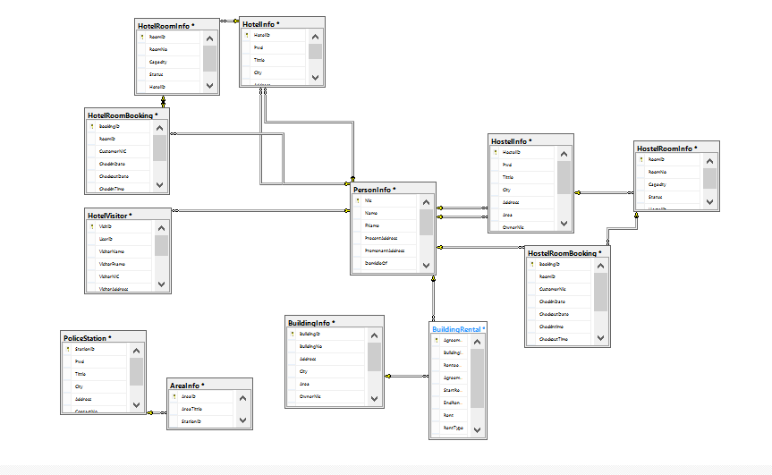

Figure 4.7: Data Base Diagram

**4.3.4 Entities with Attributes for this project**

**Admin**

Log in



Log In



AdminID



Passward

Figure 4.8: Admin

**Area Information**

Area Information

Figure 4.9: Area Information

**Building Information**

Building

Figure 4.10: Building Information

**Rented Buildings**

Rented Buildings

Figure 4.11: Rented Building

**Hostel Information**

Hostel

Figure 4.12: Hostel Information

**Hostel Room Information**

Hostel Room Information

Figure 4.13: Hostel Room Information

**Hotel Information**

Hotel

Figure 4.14: Hotel Information

**Hotel Room Information**

Hotel Room

Figure 4.15: Hotel Room Information

**Hostel Visitor**

Hostel Visitor

Figure 4.16: Hostel Visitor

**Hotel Visitor**

Hotel Visitor

Figure 4.17: Hotel Visitor

**News & Events**

News & Event

Figure 4.18: News & Events

**Person Information**

Person Information

Figure 4.19: Person Information

## 

## Police Station

## 4.4 Flow Chart:

## Figure 4.20: Police Station

Police Station

**Login:**

Invalid

Users

Users

Figure 4.21: Log In

**Change Password :**

Invalid

Check

Check

Invalid

Figure 4.21: Change Password

**Save Record:**

Check Existence

No

Yes

Input Record

Figure 4.22: Save Record

**Update Record:**

Check Existence

No

Yes

Input Record

`

Figure 4.23: Update Record

**Search Record:**

Check Existence

Yes

No

Input Record

Figure 4.24: Search Record

**Delete Record:**

Check Existence

Yes

No

Input Record

## 

## Figure 4.25: Delete Record

## 4.5 CONCLUSION

In this chapter we explained the proposed system and described the features of the proposed system. Then described the system Data Flow Diagram and Relationship Diagram which shows the working of the proposed system.

## INTRODUCTION

Once the system has been developed next phase is the system testing. Even if the system is developed using correct algorithms, its reliability remains doubtful. The validation of results is very important to make the system acceptable. Before making the system operational it is necessary to check that the new system is comprehensive with in its limits and produced the required outputs correctly.

Implementation means to adopt the newly designed system in practice. It may involve the complete implementation of computer system or the introduction of one small subsystem. The conversion of manual system into computerized data processing system is one of the, most important activity.

Implementation phase of our project cover the period from the acceptance of the test design to its satisfactory operation supported by the appropriate user and operation manual.

## 5.1 TESTING STRATEGIES

After completion of coding reviewing software and check all queries, then procedures, output, input values and triggers. We check buttons to see that they work properly check alert on execution on time and check report information for errors. Testing begins at the component level and works towards the integration of entire computer based system.

**i. VERIFICATION AND VALIDATION**

Software testing is one element of a broader topic that is defined as verification and validation. Verification; are we building the right ‘Validation; are we building the right product’.

Verification and validation encompasses wide array activities that includes formal technical review, quality and configuration audits, performance monitoring, simulation feasibility study, algorithms analysis, documentation review, database review, development testing, qualification testing and installation testing.

**ii. SYSTEM TESTING**

While developing Online System, there is tendency to push the end product “out the door “as soon as possible .Most of the time, Online projects are not estimated properly and tend to run behind schedule. When it comes to meeting the deadline, people seem to ignore a very important phase in the whole process testing. But our project has been thoroughly tested by us.

System testing is an essential step for the development of a reliable and error-free system. Testing is a process of executing a program with the explicit intension of finding errors but this does not mean to embarrass the programmer or fail the product but the positive intention to remove the problems. A test case is a set of data items that the system processes as normal input. For e.g. some alerts Special Symbols not allowed, invalid email or invalid contact no etc. Good testing involves much more than just running the program a few times to see whether it works. A successful test is the one that finds error. Here we show some alerts while input data

**Test Case 1:**

**Invalid User Passward**

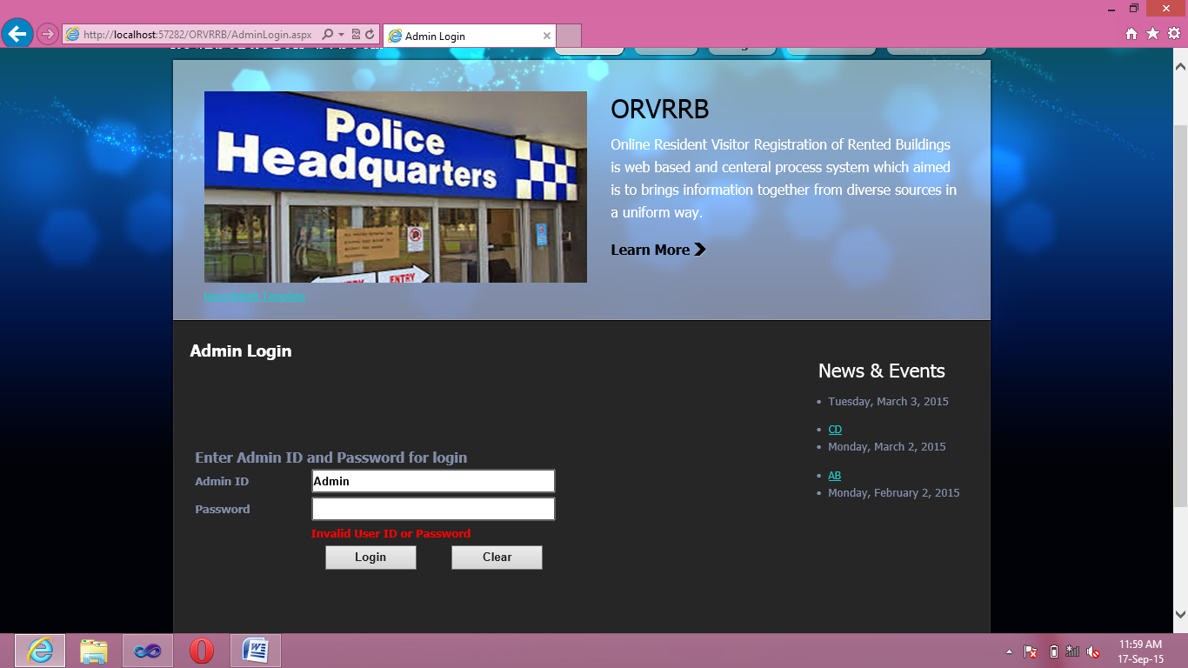

**Test Case 2:**

**Record Already Exist**

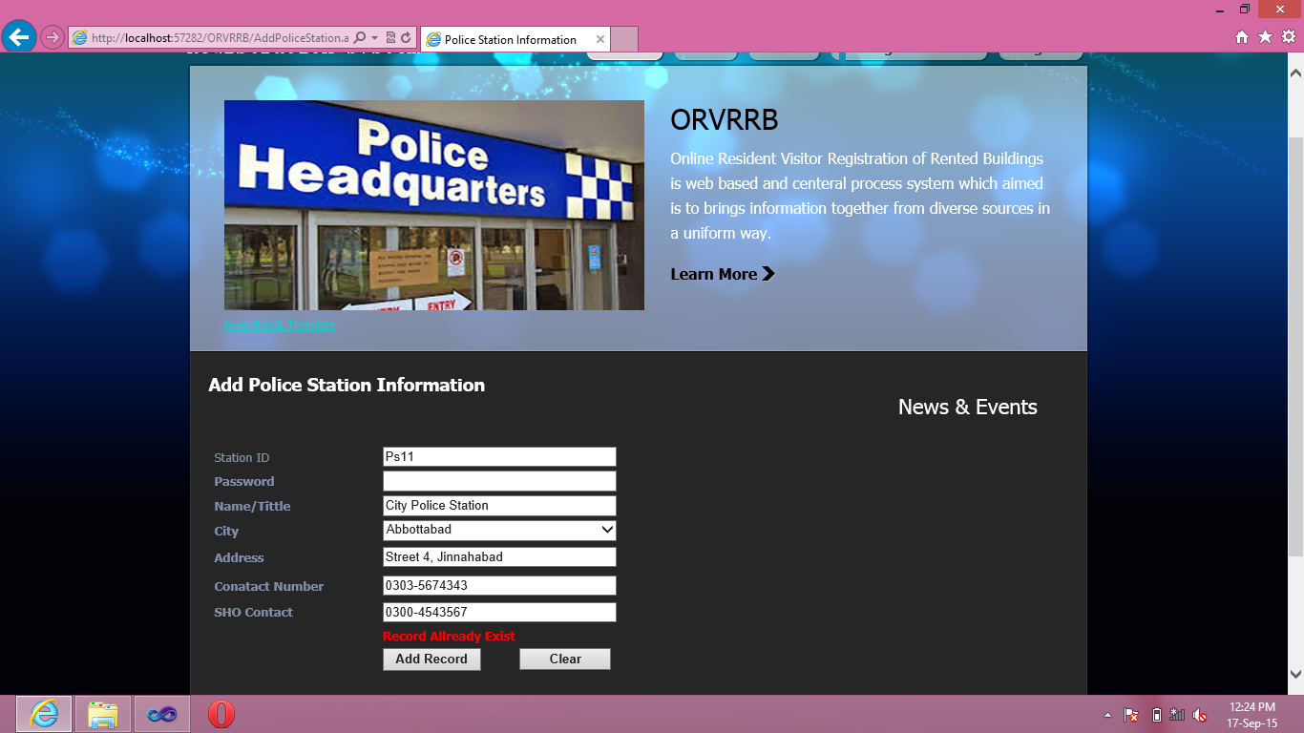

Test Case 3:

Password Doesn’t Match, Enter Correct Cell No, Invalid Email Address

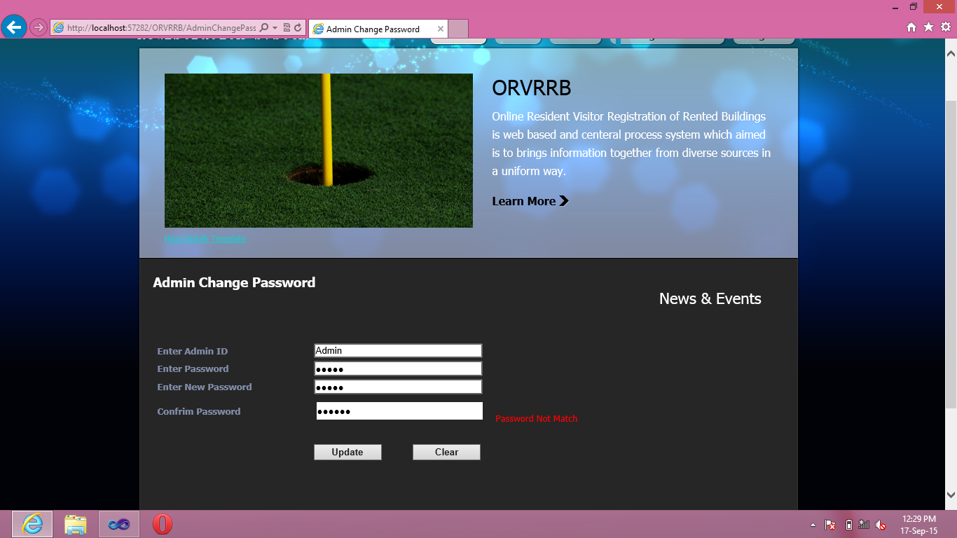

**i. COMPUTER PROGRAM TESTING**

On completion of the whole program, each module was again run from the main menu and was again tested by applying pretends data to it, for this purpose heavy data was applied to it to ensure that system is working still accurately. A large number of data is given to this project and it was tested with that data, which could not produce any errors in the project so the new system is fully tested and debugged, thus it may be implemented.

* + 1. **CODE TESTING**

These codes are test independently. All data are check with full concentration we translate the common business term and language into appropriate programming language, which is difficult task. Standard walkthrough are then used to ensure semantics correctness of code. Then correctness verification is conducted for the source code.

Coding

using System;

usingSystem.Collections.Generic;

usingSystem.Linq;

usingSystem.Web;

usingSystem.Web.UI;

usingSystem.Web.UI.WebControls;

usingSystem.Data.SqlClient;

usingSystem.Data;

usingSystem.Drawing;

usingSystem.Drawing;

publicpartialclassAdminLogin : System.Web.UI.Page

{

SqlConnection con;

Connectionconstr = newConnection();

privatevoidClr()

{

txtID.Text = "";

txtPwd.Text = "";

lblmsg.Text = "";

}

protectedvoidPage_Load(object sender, EventArgs e)

{ Labellbl = Master.FindControl("lblmaster") asLabel;

lbl.Text = "Admin Login";

lbl.ForeColor = Color.White;

// Load Event

con = newSqlConnection(constr.ConectionString);

}

protectedvoid Button1_Click(object sender, EventArgs e)

{

// Button : Login

SqlCommandcmd = newSqlCommand("select * from Admin_login where UserID ='" + txtID.Text + "' and Pwd = '" + txtPwd.Text + "'", con);

SqlDataReader r;

con.Open();

r = cmd.ExecuteReader();

if (r.Read())

{

r.Close();

con.Close();

Session["AdminID"] = txtID.Text;

Response.Redirect("AdminHome.aspx");

}

else

{

r.Close();

con.Close();

lblmsg.Text = "Invalid User ID or Password";

lblmsg.ForeColor = Color.Red;

}

}

protectedvoid Button2_Click(object sender, EventArgs e)

{

// Button : Clear

Clr();

}

}

## 5.2 PROJECT TESTING REPORT

This report includes that approximately all tests are conducted and errors are removed from software so it is ready to use.

i.  **DATA**

Data is more important element in database. It provides the base on which all the building from its source, which is form to it, destination, which is table. The order may change; we assure that all data move on its correct path.

**ii. PROCEDURES AND FUNCTIONS**

The procedures are important in testing they involve calculation of mathematics. Majority of input data is of tables we check all tables, their fields, data type, and length. But in front hand, which used by end user if the mistake is occurs like invalid data to text box the error message is display we check every text box and errors. The out of forms and fields are also tested. All field checks are show above in system testing.

iii. **GUI INTERFACE**

Interfaces are tested and it is also assured that user navigate through the screens without any errors.

iv.**TEST CASE**

A good test case is one that uses the control structures of the procedural design to drive test cases. White box testing of software is predicated on close examination of procedural detail. Using white box testing methods, the software engineer can drive test case that:

1. Guarantee that all independents paths within a module have been exercised at least once.
2. Exercise all decisions on their true and false side.
3. Execute all loops at their boundaries and within their operational bonds.
4. Exercise internal data structures to assure data validity.

## 5.3 DURING DEVELOPMENT TESTING

During development of online system, due to the nature and capabilities of tools used, testing was performed simultaneously along with the development. Resets of the bugs were removed in one-week period after website had been completely developed. Each interface was tested independently of the other to verify correct behavior and processing of data.

## 5.4 IMPLEMENTATION

Implementation means the process of transforming present manual system into new computerized system or web-based system. There are several options available for conversion. In data processing conversion is defined as the process of changing:

* From one data processing system to another.
* From one from of representation to the other.

Implementation of project involves the following activities.

* Planning and scheduling of the implementation processes.
* Organizational planning and personal administration.
* Final system designed and testing.
* Establishment of standard of performance and control procedures and conversion from old to new system.

## 5.5 CONVERSION

There are several conversion options that will reduce the risk of mishap in the new system. The main purpose in conducing study is to argue for one method of conversion over the by studying keenly the advantages and limitation of both conversion method and implementation phase is rigidly based on this comparative study. There are four basic patterns when implementing the new system.

* Direct conversion
* Gradual conversion
* Parallel conversion
* Pilot conversion

### 5.5.1 DIRECT CONVERSION METHOD

Direct conversion method stresses upon the introduction of a completely new system without any reference to the existing system. It is very risky. However it is simple and cheapest conversion method. In it the old system stops at the given data and the new one begins. There is no way to go back. Implied in their system method is the assumption that the system has been tested fully and not fail. This method is not suitable because the chances of the failure are more than other conversion methods.

### 5.5.2 GRADUAL CONVERSION METHOD

Gradual conversion technique allows one program at a time to replace an activity of the existing system. Gradually, the present system is replaced by the newly designed system. Small scale operations are conducted first to confirm that this changeover will be successful. When the new system is completed tested, the old system is not used any more and new system is completely take over. The process continuous until the new system is fully implemented.

### 5.5.3 PILOT CONVERSION METHOD

In pilot conversion method, the new system is implemented in parts, as it proved that the new system is producing the required results, the system is implemented in the whole organization. As the developed system works as a unit so the pilot conversion is not suitable.

### 5.5.4 PARALLEL CONVERSION METHOD

In parallel conversion technique both, the existing system and the new system run simultaneously. Data is processed or moved through systems concurrently and only when the new system is checked out, the operation of an old system is stopped. It is believed that the safest approach to conversion is run both new and old system at the same time, until it is satisfactorily established that the new system is producing reliable results. It provides the old system as backup, in case the new system fails.

### 5.5.5 PROPOSED CONVERSION METHOD

The most feasible conversion technique, which suits the best, is parallel conversion. It is selected because it provides an opportunity to compare the results of the existing system with those of the developed system. Other advantages of this approach are that the risk of failure is covered. Although this implementation will slightly expensive and increases additional workload, the system will be safe and the procedure should be followed for some time until it is confirm that the newly designed system is working perfectly.

## 5.6 CONCLUSION

The project has been completed successfully, meeting most of the objectives laid down at the start of the project, in the allocated course of time.

The new system is ready to replace the old manual system. It meets all the requirements of the user and has an easy to understand and user-friendly interface.

## INTRODUCTION

The Interface designing is the basic building block of any website. The interface-design depends upon the forms/interface of the present system and the vision and approach of the web designer for the proposed system.

**6.1 Home or Index Page**

**Description:** This is Main page of  **Online Resident/Visitor Registration of Rented Buildings**.

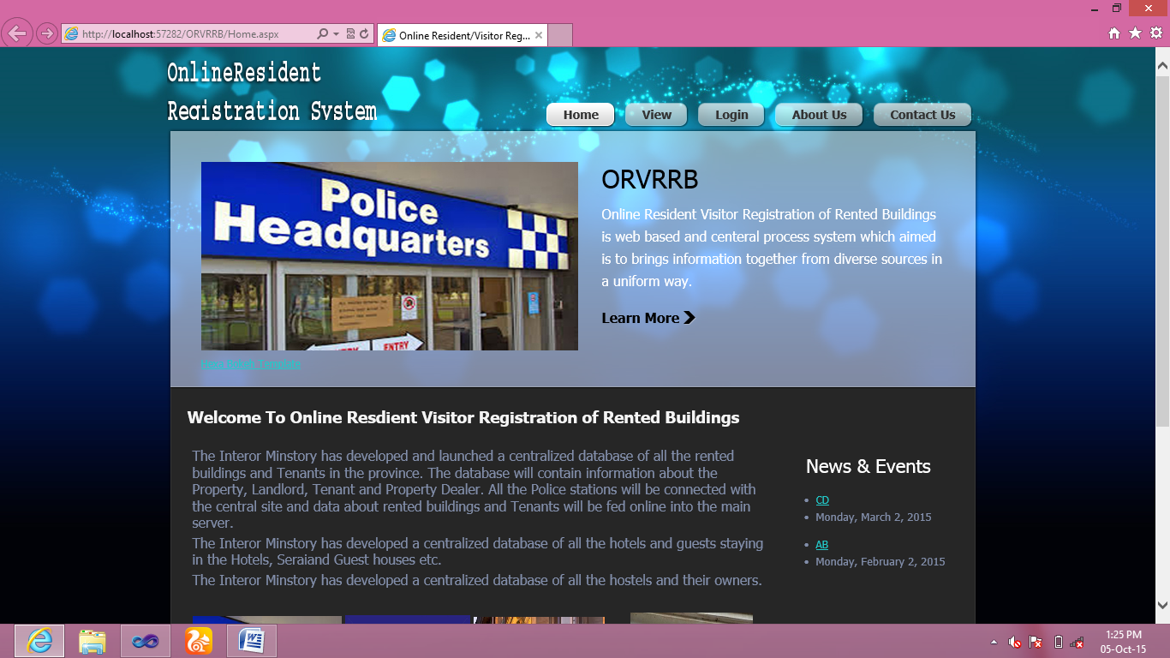

Figure 6.1: Home Or Index Page

## 

**6.2 Police Station Login.**

**Description:** This Is Login Page Of Police Station



Figure 6.2:Police Station Login Form

**6.3 Police Station Record**

**Description:**This Page Add Police Station Record

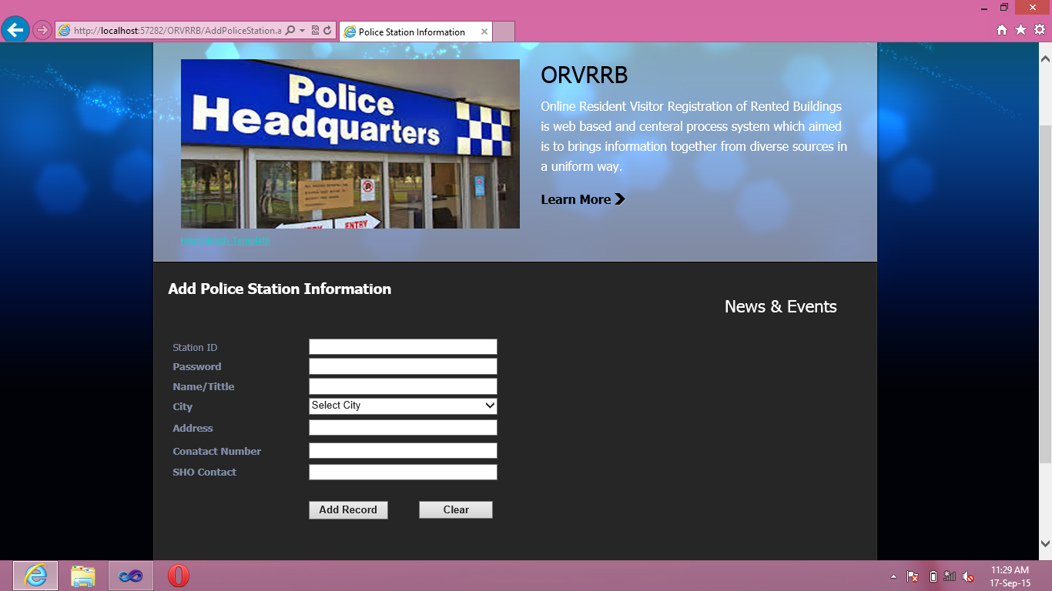

Figure 6.3: Police Station Record Form

**6.4 Add Person Information**

**Description:** This Page Add Person Information

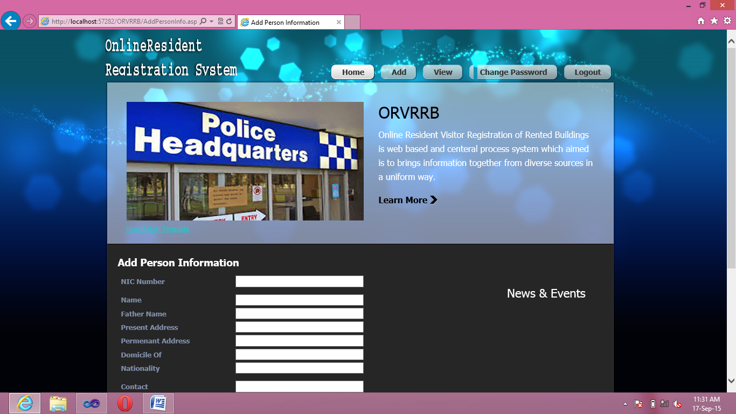

Figure 6.4: Person Information Form

**6.5 Add Hostel Information**

**Description:** This Page Add Hostel Information

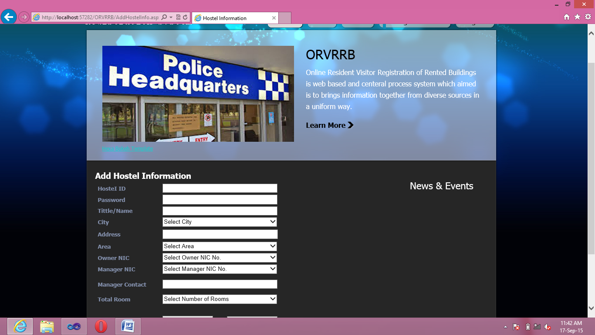

Figure 6.5: Hostel Information Form

**6.6 Add Hotel Information**

**Description:** This Page Add Hotel Information

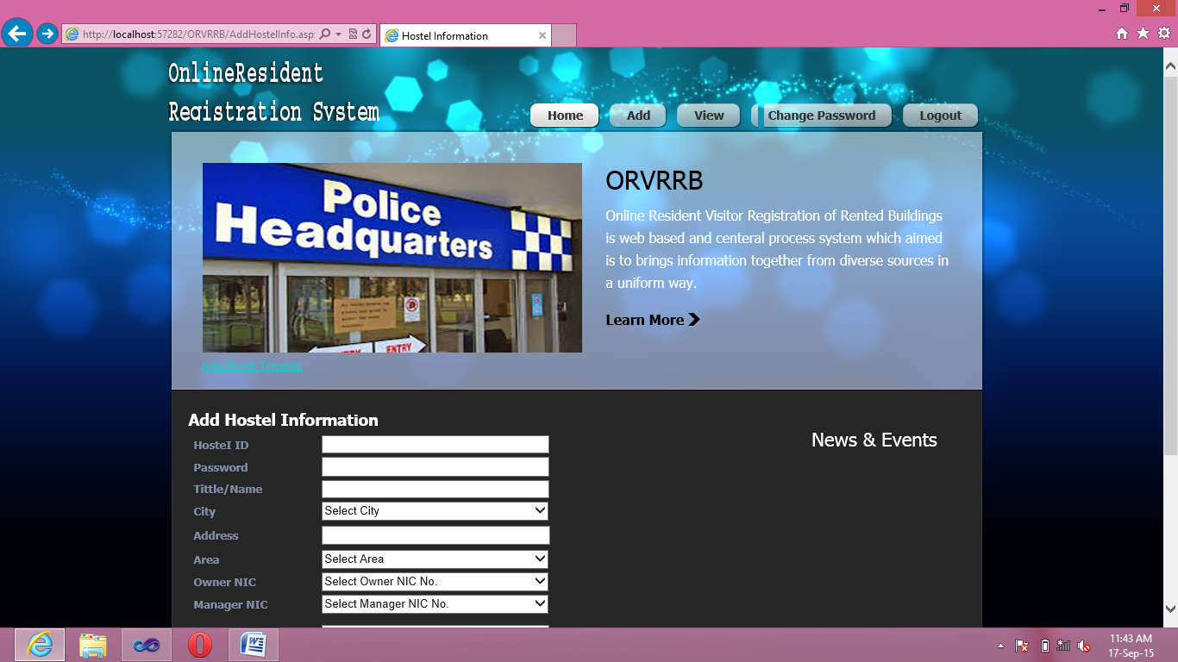

Figure 6.6: Hotel Information Form

**6.7 View Hostel Information**

**Description:** This Page View Hostel Information

.

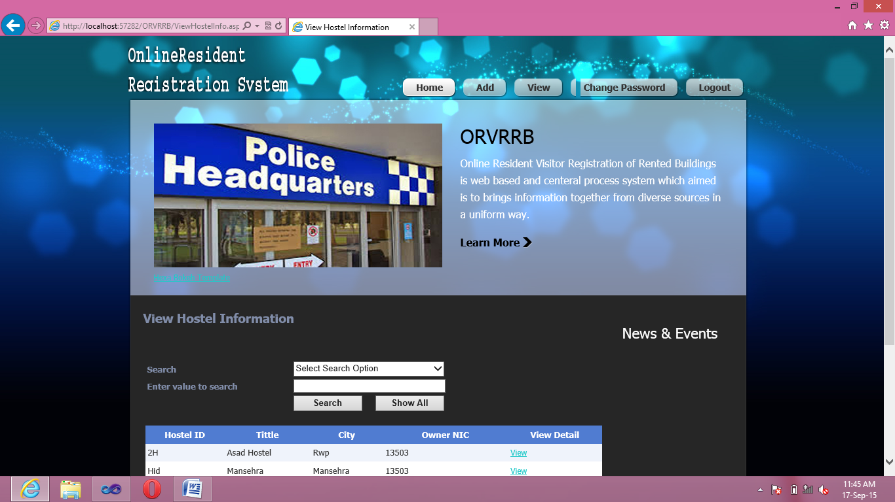

Figure 6.7: View Hostel Information Form

**6.8 Detail Hostel Information**

**Description:** This is Detail Hostel Information Page

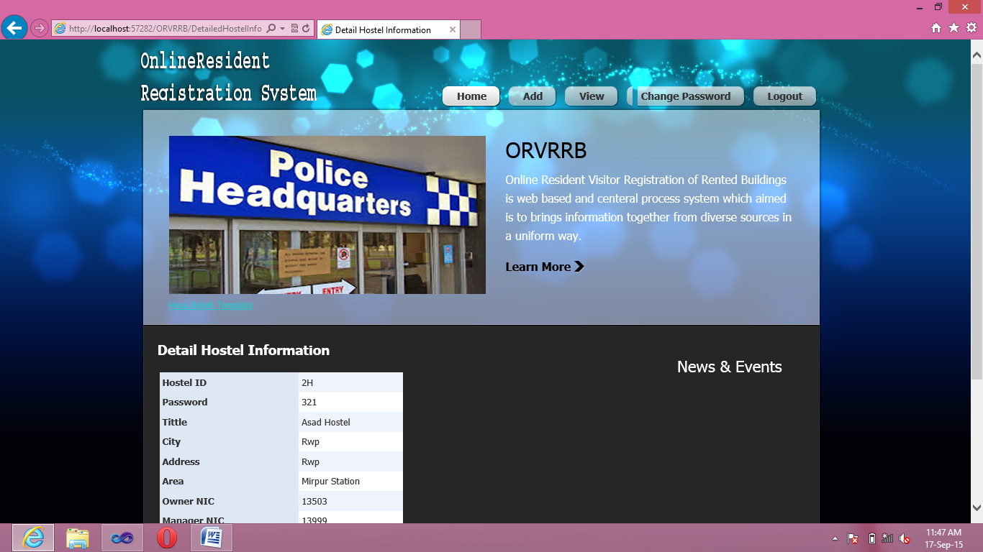

Figure 6.8: Detail Hostel Information

**6.9 Update/ Delete Person Information**

**Description:** This Page Update And Delete Person Information

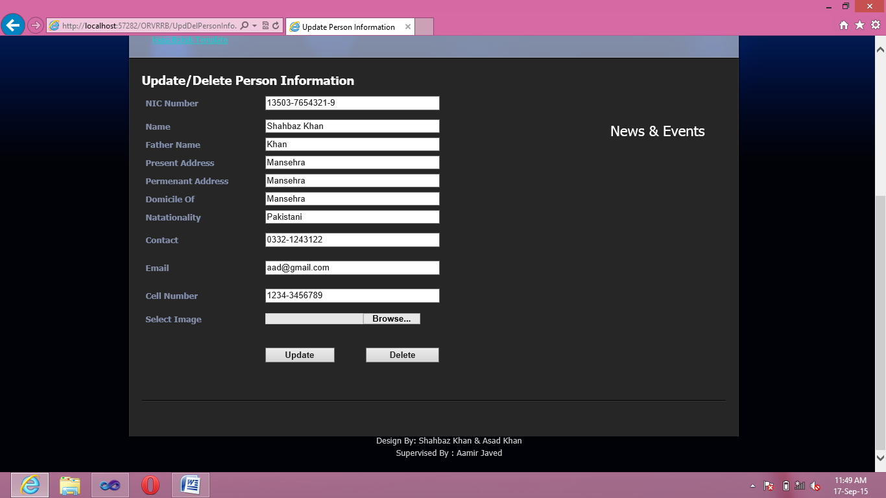

Figure 6.9: Update/delete Person Information Form

**6.10 Update/Delete Police Station Information**

**Description:** This Page Update And Delete Police Station Information

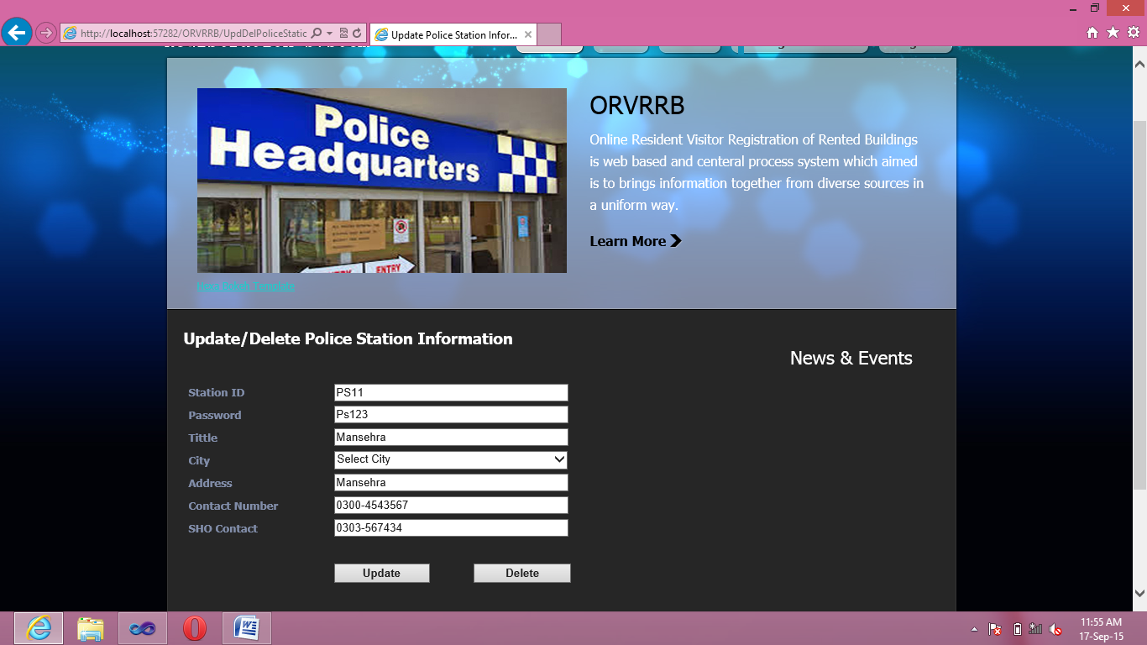

Figure 6.10: Update/delete Police Station Information Form

**6.11 Detail Hotel Information**

**Description:** This Is Detail Information Form Of Hotel

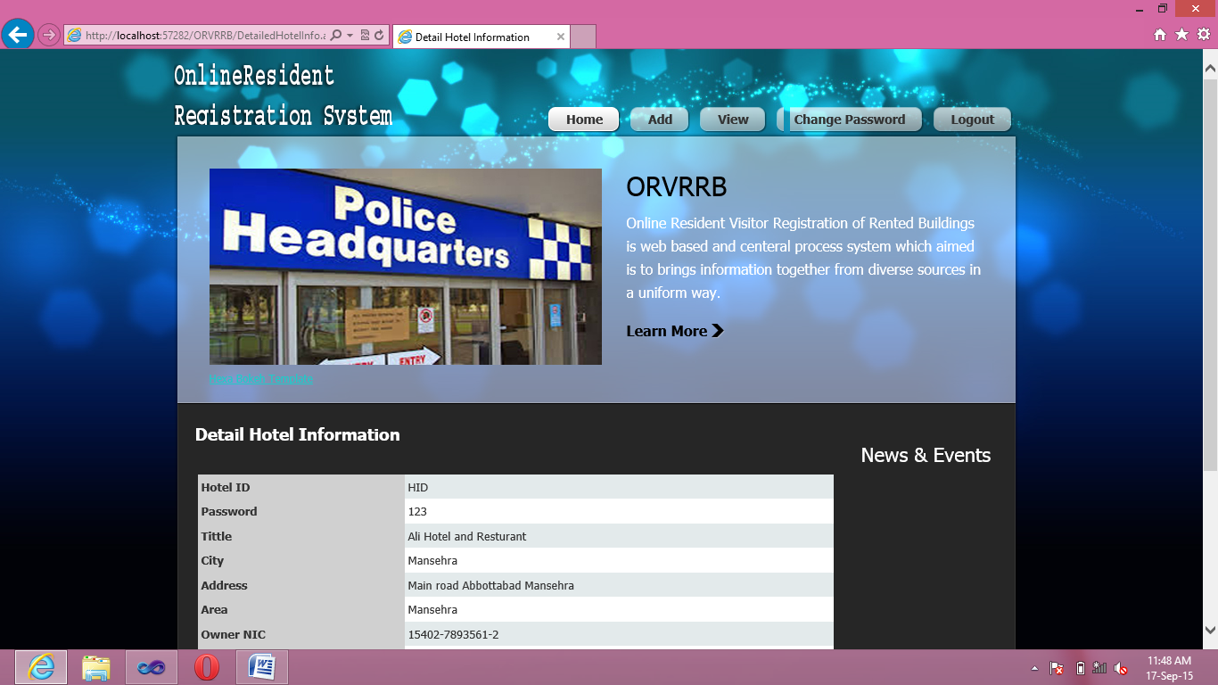

Figure 6.11:Detail Hotel Information Form

## Data Dictionary for this Project:

All tables used in this project and their field names, their data types, sizes and their Full Names are described below:

1. **Admin Login**

Primary Key: Admin ID

|  |  |  |
| --- | --- | --- |
| **Field Name** | **Data Type** | **Description** |
| Admin ID | Varchar (150) | Admin ID |
| Pwd | Varchar(50) | Password |

Table 7.1:Admin Login

1. **Area Information**

Primary Key: Area ID

Foreign Key : Station ID

|  |  |  |
| --- | --- | --- |
| **Field Name** | **Data Type** | **Description** |
| Area ID | unique identifier | Area ID |
| Area Tiitle | Varchar(250) | Area Tittle |
| Station ID | Varchar(150) | Station ID |

Table 7.2: Area Information

1. **Building Information**

Primary Key : Building ID

Foreign Key : Owner Nic, City

|  |  |  |
| --- | --- | --- |
| **Field Name** | **Data Type** | **Property** |
| Building ID | unique identifier | Building ID |
| Building Number | Varchar(50) | Building Number |
| Address | Varchar(250) | Address |
| City | Varchar(50) | City |
| Area | Varchar(250) | Area |
| Owner NIC | Varchar(50) | Owner NIC |
| Type | Varchar(50) | Type |
| Ownership Type | Varchar(50) | Ownership Type |
| Founded Date | Date | Founded Date |
| Status | Varchar(50) | Status |

Table 7.3: Building Information

1. **Rented Building**

Primary Key : Agreement ID

Foreign Key : Building ID, Gurantee1 NIC, Gurantee2 NIC

|  |  |  |
| --- | --- | --- |
| **Field Name** | **Data Type** | **Description** |
| Agreement ID | Varchar(150) | Agreement Id |
| Building ID | unique identifier | Building ID |
| Agreement Date | Date | Agreement Date |
| Start Rent | Date | Start Rent |
| End Rent | Date | End Rent |
| Rent | Varchar(50) | Rent |
| Rent Type | Varchar(50) | Rent Type |
| Guarantee1 NIC | Varchar(50) | Gurantee1 NIC |
| Gurantee2 NIC | Varchar(50) | Gurantee2 NIC |

Table 7.4: Rented Building

1. **Hostel Information**

Primary Key : Hostel ID

Foreign Key : City, Owner NIC, Manager NIC

|  |  |  |
| --- | --- | --- |
| **Field Name** | **Data Type** | **Description** |
| Hostel ID | Varchar(250) | Hostel ID |
| Pwd | Varchar(50) | Password |
| Tittle | Varchar(50) | Tittle |
| City | Varchar(50) | City |
| Address | Varchar(250) | Address |
| Area | Varchar(250) | Area |
| Owner NIC | Varchar(50) | Owner NIC |
| Manager NIC | Varchar(50) | Manager NIC |
| Manager Contact | Varchar(50) | Manager Contact |

Table 7.5:Hostel Information

1. **Hostel Room Information**

Primary Key : Room ID

Foreign Key : Hostel ID

|  |  |  |
| --- | --- | --- |
| **Field Name** | **Data Type** | **Description** |
| Room ID | unique identifier | Room ID |
| Room Number | Varchar(50) | Room Number |
| Capacity | Int | Capacity |
| Status | Varchar(50) | Status |
| Hostel ID | Varchar(50) | Hostel ID |

Table 7.6: Hostel Room Information

1. **Hostel Room Booking**

Primary Key : Booking ID

Foreign Key : Room ID, Customer NIC

|  |  |  |
| --- | --- | --- |
| **Field Name** | **Data Type** | **Description** |
| Booking ID | unique identifier | Booking ID |
| Room ID | unique identifier | Room ID |
| Customer NIC | Varchar(50) | Customer NIC |
| Checkin Date | Date | Checkin Date |
| Checkout Date | Date | Checkout Date |
| Checkin Time | Varchar(50) | Checkin Time |
| Checkout Time | Varchar(50) | Checkout Time |
| Status | Varchar(50) | Status |
| Rent Type | Varchar(50) | Rent Type |

Table 7.7: Hostel Room Information

1. **Hotel Information**

Primary Key : Hotel ID

Foreign Key : City, Owner NIC, Manager NIC

|  |  |  |
| --- | --- | --- |
| **Field Name** | **Data Type** | **Description** |
| Hotel ID | Varchar(250) | Hostel ID |
| Pwd | Varchar(50) | Password |
| Tittle | Varchar(50) | Tittle |
| City | Varchar(50) | City |
| Address | Varchar(250) | Address |
| Area | Varchar(250) | Area |
| Owner NIC | Varchar(50) | Owner NIC |
| Manager NIC | Varchar(50) | Manager NIC |
| Manager Contact | Varchar(50) | Manager Contact |
| Total Room | Int | Total Room |

Table 7.8: Hotel Information

1. **Hotel Room Information**

Primary Key : Room ID

Foreign Key : Hotel ID

|  |  |  |
| --- | --- | --- |
| **Field Name** | **Data Type** | **Description** |
| Room ID | unique identifier | Room ID |
| Room Number | Varchar(50) | Room Number |
| Capacity | Int | Capacity |
| Status | Varchar(50) | Status |
| Hotel ID | Varchar(50) | Hostel ID |

Table 7.9: Hotel Room Information

1. **Hotel Room Booking**

Primary Key : Booking ID

Foreign Key : Room ID , Customer NIC

|  |  |  |
| --- | --- | --- |
| **Field Name** | **Data Type** | **Description** |
| Booking ID | unique identifier | Booking ID |
| Room ID | unique identifier | Room ID |
| Customer NIC | Varchar(50) | Customer NIC |
| Checkin Date | Date | Checkin Date |
| Checkout Date | Date | Checkout Date |
| Checkin Time | Varchar(50) | Checkin Time |
| Checkout Time | Varchar(50) | Checkout Time |
| Status | Varchar(50) | Status |

Table 7.10: Hotel Room Information

1. **Hostel Visitor**

Primary Key : Visitor ID

Foreign Key : User ID

|  |  |  |
| --- | --- | --- |
| **Field Name** | **Data Type** | **Description** |
| Visitor ID | Int | Visitor ID |
| User ID | Varchar(50) | User ID |
| Visitor Name | Varchar(50) | Visitor Name |
| Visitor Father Name | Varchar(50) | Visitor Father Name |
| Visitor NIC | Varchar(15) | Visitor NIC |
| Visitor Address | Varchar(500) | Visitor Address |
| Visitor Contact | Varchar(50) | Visitor Contact |
| In Time | Varchar(50) | In Time |
| Out Time | Varchar(50) | Out Time |
| Date | Date | Date |

Table 7.11: Hotel Visitor

1. **Hotel Visitor**

Primary Key : Visitor ID

Foreign Key : User ID

|  |  |  |
| --- | --- | --- |
| **Field Name** | **Data Type** | **Description** |
| Visitor ID | Int | Visitor ID |
| User ID | Varchar(50) | User ID |
| Visitor Name | Varchar(50) | Visitor Name |
| Visitor Father Name | Varchar(50) | Visitor Father Name |
| Visitor NIC | Varchar(15) | Visitor NIC |
| Visitor Address | Varchar(500) | Visitor Address |
| Visitor Contact | Varchar(50) | Visitor Contact |
| In Time | Varchar(50) | In Time |
| Out Time | Varchar(50) | Out Time |
| Date | Date | Date |

Table 7.12: Hotel Visitor

1. **Personal Information**

Primary Key : NIC

|  |  |  |
| --- | --- | --- |
| **Field Name** | **Data Type** | **Description** |
| NIC | Varchar(15) | NIC |
| Name | Varchar(50) | Name |
| Father Name | Varchar(50) | Father Name |
| Present Address | Varchar(500) | Present Address |
| Permanent Address | Varchar(500) | Permanent Address |
| Domicile | Varchar(50) | Domicile |
| Natationality | Varchar(50) | Natationality |
| Contact | Int | Contact |
| Email | Varchar(50) | Email |

Table 7.13: Person Information

1. **Police Station**

Primary Key : Station ID

|  |  |  |
| --- | --- | --- |
| **Field Name** | **Data Type** | **Description** |
| Station ID | Int | Station ID |
| Pwd | Varchar(50) | Password |
| Title | Varchar(50) | Tittle |
| City | Varchar(50) | Cit |
| Address | Varchar(50) | Address |
| Contact | Int | Contact |
| SHO Contact | Int | SHO Contact |

Table 7.14: Police Station

1. **Student Out Pass**

Primary Key :Outpass ID

Foreign Key : User ID

|  |  |  |
| --- | --- | --- |
| **Field Name** | **Data Type** | **Description** |
| OutpassID | Int | Outpass ID |
| User ID | Varchar(50) | User ID |
| Out Date | Date | Out Date |
| Out Time | Time | Out Time |
| Return Date | Date | Return Date |
| Return Time | Time | Return Time |
| Remarks | Varchar(500) | Remarks |

Table 7.16: Student Out Pass

1. **News Event**

Primary Key : News ID

|  |  |  |
| --- | --- | --- |
| **Field Name** | **Data Type** | **Description** |
| News ID | Int | News ID |
| Title | Varchar(50) | Tittle |
| Description | Varchar(250) | Description |
| Post Date | Date | Post Date |

Table 7.16: News Events

1. **Feedback**

Primary Key : Feedback ID

|  |  |  |
| --- | --- | --- |
| **Field Name** | **Data Type** | **Description** |
| Feedback ID | Int | Field ID |
| Sender Name | Varchar(50) | Sender Name |
| Contact Number | Int | Contact Number |
| Email | Varchar(50) | Email |
| Subject | Varchar(50) | Subject |
| Type | Varchar(50) | Type |
| Description | Varchar(500) | Description |

Table 7.17: Feedback

# 

# References

* Jeffery A. Hoofer, Mary B Prescott & Fred R McFadden - Modern Database Management (Eighth Edition).
* Kenneth E Kendall & Julie - System Analysis and Design.
* RogerSPressman - Software Engineering
* C# How to Program by Detail.
* Addison Wesley - Developing Applications with Visual Studio.
* Addison Wesley-A Developer’s guide to SQL Server 2005.
* IT Series A Fundamental Study of Database Management System.